Table of Contents

Introduction 1

1.1. Purpose 1

1.2. Scope of Project 1

1.3. Glossary 1

1.4. References 2

2.0. Overall Description 2

2.1 System Environment 2

2.2 Functional Requirements Specification 3

2.2.1 Student Use Case 3

2.2.2 Counsellor 4

2.2.3 Dean 5

3.0. Requirements Specification 6

3.1 External Interface Requirements 6

3.2 Functional Requirements 6

3.2.1 Book Appointment 6

3.2.2 Set Schedule 7

3.2.3 System Management 7

3.3 Detailed Non-Functional Requirements 8

3.3.1 Logical Structure of the Data 8

3.3.2 Security 10

SOFTWARE DESIGN DOCUMENTATION 11

4. INTRODUCTION. 12

4.1.1 Purpose and Scope 12

4.2.2 System Overview 13

4.2 Design Constraints. 13

4.2.1 Future Contingencies 14

4.2.2 Document Organization 14

4.3 Points of Contact 14

4.4 Glossary 15

5. SYSTEM ARCHITECTURE. 17

5.1 System Hardware Architecture 19

6. FILE AND DATABASE DESIGN 20

6.1 Database Management System Files 22

7.HUMAN-MACHINE INTERFACE. 23

a) HOMEPAGE LAYOUT 23

b) Color scheme 23

c) Information presentation 23

7.1 Outputs 25

7.2 GUI 25

8 DETAILED DESIGN 26

8.1 Hardware Detailed Design 26

8.2 Software Detailed Design 26

9 Use case Realization 31

10.0 SYSTEM INTEGRITY CONTROLS 32

TEST PLAN 33

INTRODUCTION 34

11.1 PURPOSE 34

11.2 AUDIENCE 34

12. TEST STRATEGY 35

12.1.1 Test Objectives 35

12.1.2 Test Assumptions 35

12.1.3 Test Principles 35

12.1.4 Data Approach 36

12.2 Scopes and Levels of Testing 36

12.2.1 Functional Testing 36

12.2.2 System Testing 36

12.2.3 Integration Testing 36

12.2.4 Regression Testing 36

12.2.5 User Acceptance Testing 36

12.3 Testing Deliverables 37

12.4 Test Environment 37

12.5 Levels and Impacts of the Defects 37

13. ROLES AND EXPECTATIONS 38

13.1 Project Manager 38

13.2 Test Lead (Test Planning) 38

13.3 Test Team 38

13.4 Test Lead 38

13.5 Development Team 38

USER MANUAL 40

14.1 GENERAL INFORMATION 41

14.2 System Overview 41

14.3 SYSTEM SUMMARY 41

14.4 System Configuration 41

14.5 User Access Levels 42

14.6 Contingencies 42

15.0 GETTING STARTED 42

15.1 Set – up consideration 42

15.2 Accessing the system 42

15.2.1 System Organization & Navigation 43

15.2.1 Student activities 43

Counsellor activities 45

15.2.2 Dean Activities 47

15.2.3 About us 50

15.2.4 Contact us 50

15.2.5 Exiting the System 50

15.2.6 Troubleshooting and Support 50

15.2.7 ***Error Messages*** 50

16. Support 51

Appendix 51

# SYSTEM REQUIREMENT SPECIFICATION

# Introduction

## 1.1. Purpose

The purpose of this document is to present a detailed description of the Online Appointment Booking System. It will explain the purpose and features of the system, the interfaces of the system, what the system will do, the constraints under which it must operate and how the system will react to external stimuli. This document is intended for both the stakeholders and the developers of the system and will be proposed to the Egerton University Dean of students’ office and Counselling Department Njoro Campus.

## 1.2. Scope of Project

This software system will be an Online Appointment Booking System for Egerton University Dean of students’ office and Counselling Department Njoro Campus. This system will be designed to maximize time utilization and elimination of concurrence situations under which students face while they make a visit to counselling and dean offices and facilitate service to all, which would otherwise have to be performed manually. By maximizing the counsellor work efficiency, the system will meet the student, counsellor and dean needs while remaining easy to understand and use.

More specifically, this system is designed to allow the students to book appointments and get attended to by counsellors and dean as well. The software will facilitate communication between students, counsellors, and the dean via E-Mail. The system also contains a relational database containing a list of sessions booked, counsellor schedules, students who are registered for counselling services and a list of counsellors.

## 1.3. Glossary

|  |  |
| --- | --- |
| **Term** | **Definition** |
| Database | Collection of all the information monitored by this system. |
| Field | A cell within a form. |
| Student | A person registered for an undergraduate course to take studies in Egerton university Njoro Campus. |
| Counsellor | Staff member who will be issuing services to students. |
| Dean | Head of student dean department. |
| Software Requirements Specification | A document that completely describes all of the functions of a proposed system and the constraints under which it must operate. For example, this document. |
| Stakeholder | Any person with an interest in the project who is not a developer. |
| User | Student, counsellor or dean. |

## 1.4. References

IEEE. *IEEE Std 830-1998 IEEE Recommended Practice for Software Requirements Specifications.* IEEE Computer Society, 1998.

## 2.0. Overall Description

# 2.1 System Environment

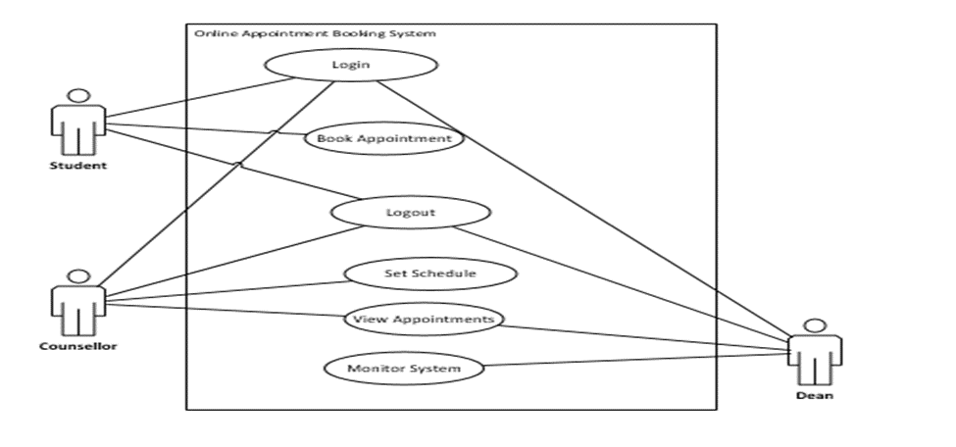

Figure 1 - System Environment

The Online Appointment Booking System has three active actors.

The student, counsellor and dean access the online services through the Internet. Any student, counsellor or dean communication with the system is through email. The Dean accesses the entire system directly.

## 2.2 Functional Requirements Specification

This section outlines the use cases for each of the active users of the system separately. The counsellor and the student have only one-use case a piece while the Dean is the main actor in this system.

### 2.2.1 Student Use Case

**Use case:**  Book Appointment.

**Diagram:**

Student

Book App.

Figure 2 - Student Use Case

**Brief Description**

The student accesses the online website, searches for a counsellor who is free and books appointment to see the counsellor.

**Initial Step-By-Step Description**

Before this use case can be initiated, the Reader has already accessed the Online Appointment Booking Website.

1. The student logs in the system using registration number or email.
2. The student checks for sessions that have not been booked by checking on the booked schedules.
3. The system provides links for booking appointments and viewing booked sessions.
4. The student clicks the link to book appointment.
5. The student selects the counsellor whom she or he wants to see.
6. The student picks date that he/she wants to see the counsellor.
7. The student picks time that he/she wants to see the counsellor.
8. The student books appointment.

### 2.2.2 Counsellor

In case of long term schedule, the dean of students is manually contacted. The counsellor logs in the online appointment booking website where he/she sets time of unavailability.

**Use case: Set Schedule**

**Diagram:**

Counsellor

Set Schedule

Figure 3 - Counsellor Use Case

**Brief Description**

The author counsellor sets a schedule only for the time he/she will not be available.

**Initial Step-By-Step Description**

Before this use case can be initiated, the counsellor has already connected to the Online Appointment Booking System.

1. The counsellor clicks a link to set the schedule.
2. The counsellor selects the time in which he/she will be away.
3. The counsellor picks number of hours he/she will be away.
4. The counsellor picks time he/she will be away.
5. The counsellor picks the number of days he/she will be away if any.
6. The counsellor provides a reason he/she will be away.

### 2.2.3 Dean

Use case: Management of system

**Diagram:**

Figure 3 - Dean Use Case

Dean

Manage

**Brief Description**

The Dean conducts all the managerial activities of the system.

**Initial Step-By-Step Description**

Before this use case can be initiated, the Dean has already connected to the Online Appointment Booking Website.

1. The dean logs in the system using username and a password..
2. The System uses authentication function to validate the system user.
3. The dean conducts all the managerial activities of the system as assigned.

## 3.0. Requirements Specification

## 3.1 External Interface Requirements

The system has been integrated to work only on the internal environments under which all users of the system must register with the counselling appointment booking system in order to access services provided by the system.

## 

## 3.2 Functional Requirements

The Logical Structure of the Data is contained in Section 3.3.1.

### 3.2.1 Book Appointment

|  |  |
| --- | --- |
| **Use Case Name** | Book Appointment |
| **Trigger** | The student assesses the Online Appointment booking system |
| **Precondition** | The student must be logged in and Web is displayed with menu addresses for booking |
| **Basic Path** | 1. The student logs in the system using registration number or email. 2. The student checks for sessions that have not been booked by checking on the booked schedules. 3. The system provides links for booking appointments and viewing booked sessions. 4. The student clicks the link to book appointment . 5. The student selects the counsellor whom she or he wants to see. 6. The student picks date that he/she wants to see the counsellor. 7. The student picks time that he/she wants to see the counsellor. 8. The student books appointment. |
| **Post condition** | An email is sent to the counsellor informing for the same. |
| **Exception Paths** | The student may abandon booking at any instance. |

### 3.2.2 Set Schedule

|  |  |
| --- | --- |
| **Use Case Name** | Set Schedule |
| **Trigger** | The counsellor assesses the Online Appointment booking system |
| **Precondition** | The counsellor must be logged in and Web is displayed with menu addresses for setting schedules. |
| **Basic Path** | 1. The counsellor clicks a link to set the schedule. 2. The counsellor selects the time in which he/she will be away. 3. The counsellor picks number of hours he/she will be away. 4. The counsellor picks time he/she will be away. 5. The counsellor picks the number of days he/she will be away if any. 6. The counsellor provides a reason he/she will be away. |
| **Post condition** | The message is sent to the dean informing for the same. |
| **Exception Paths** | The attempt may be abandoned at any time. |
| **Other** | None |

### 3.2.3 System Management

|  |  |
| --- | --- |
| **Use Case Name** | Manage System |
| **Trigger** | The dean assesses the Online Appointment booking system |
| **Precondition** | The dean must be logged in and Web is displayed with menu addresses for managerial activities. |
| **Basic Path** | 1. The dean logs in the system using username and a password.. 2. The System uses authentication function to validate the system user. 3. The dean conducts all the managerial activities of the system as assigned. |
| **Postcondition** | Approval status updated |
| **Exception Paths** | The dean may abandon the operation at any time. |
| **Other** | None. |

## 3.3 Detailed Non-Functional Requirements

### 3.3.1 Logical Structure of the Data

The logical structure of the data to be stored in the Online Appointment database is given below.

The data descriptions of each of these data entities is as follows:

**Dean Data Entity**

|  |  |  |  |
| --- | --- | --- | --- |
| **Data Item** | **Type** | **Description** | **Comment** |
| User Name | String | Name of the dean |  |
| Password | String | Secret Password |  |
| Admin Id | Short Integer | Dean entry no. | Used as a key. |
| Email Address | String | Email address of the dean |  |

**Counsellor Data Entity**

|  |  |  |  |
| --- | --- | --- | --- |
| **Data Item** | **Type** | **Description** | **Comment** |
| Counsellor Name | String | Name of the counsellor |  |
| Counsellor no. | Integer | The office number the counsellor is assigned | Used as key in searching available counsellors |
| Email Address | Text | Internet address |  |
| Phone No. | Integer | Counsellors cell phone | May be several |

**Schedule Data Entity**

|  |  |  |  |
| --- | --- | --- | --- |
| **Data Item** | **Type** | **Description** | **Comment** |
| Away date | date | The date the counsellor will be away |  |
| Away Time | Time | The time the counsellor will be away |  |
| Away Period | Integer | The duration the counsellor will be away |  |
| Next time available | Time | Date returned; null if not returned |  |
| Next Available date | Date | The next time the counsellor will be available |  |
| Reason | Text | Reason for unavailability |  |
| Approval | Text | Status of the schedule set |  |
| Counsellor No. | Text | The counsellors’ office number |  |
| Counsellor Name. | Text | The name of the counsellor |  |

**Sessions Data Entity**

|  |  |  |  |
| --- | --- | --- | --- |
| **Data Item** | **Type** | **Description** | **Comment** |
| Reg. No. | String | The students’ registration number. |  |
| Student Name | Text | The name of the student |  |
| Counsellor No. | String | The name of the counsellor picked |  |
| Date | Date | The date the student will see the counsellor |  |
| Start Time | Text | The time the student will see the counsellor |  |
| End Time | Text | The time the booked session will be off |  |
| Session ID | Integer | The number that distinguishes sessions | A key for searching different sessions |

The Logical Structure of the data to be stored in the Online Journal database on the server is as follows:

**Student Data Entity**

|  |  |  |  |
| --- | --- | --- | --- |
| **Data Item** | **Type** | **Description** | **Comment** |
| User Id | Integer | Distinguishes students and helps identify the number of students in the database |  |
| User Email | String | The students’ email address |  |
| User password | String | The password student uses to login the system |  |
| Reg. No. | String | Students’ registration number | Key for searching students in the database |
| Name | String | The students’ name |  |
| Phone No. | Integer | The students’ contacts |  |

### 3.3.2 Security

The server on which the online appointment booking resides will have its own security to prevent unauthorized *write*/*delete* and *read* access. The PC on which the Online Appointment Booking system resides will have its own security.

# SOFTWARE DESIGN DOCUMENTATION

## 4. INTRODUCTION.

### 4.1.1 Purpose and Scope

This document describes the design for the dean of students’ online counselling appointment booking system. This system will be developed to replace the existing manual system. It will provide effective counseling appointment scheduling for Egerton University students. This system was designed considering the following goals:

**Scalability**

The system must be scalable in terms that it can support many users communicating

**Usability**

Since the end-user will be using the system while performing work, it is essential for the system to be intuitive and easy to use.

**Multiple Users**

The system should support tasks that are performed by multiple users in concert, supplying each with the necessary information and statuses at the appropriate time.eg the student must be in a position to tell the available counselors and counselors must be in a position to set their availability and know pending appointment requests.

**Scope of the System**

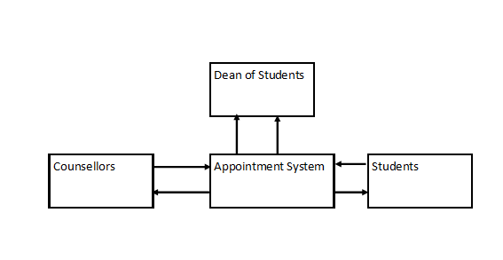

Fig.1.1 booking appointment System Scope

### 4.2.2 System Overview

Online counselling appointment system is an on line students counseling appointment system to be used by undergraduate students in Egerton University. The availability of counselors determines the capability of students to book an appointment and proceed on and meet a counselor of their choice. This will allow counselors to plan their work early since there will be a system facilitating prior scheduling.

This system will provide a platform for preparation and communication between students and their counselors as far as setting an appointment is concerned. Counselors will be receiving alerts via email as soon as the students book an appointment.

The dean of students can add a counsellor, remove, approve their permission to be away and print reports on counselling appointments and schedules. The dean will also know from his/her desk of the available counselors and those planning to be away.

This application will maintain the entire data in a centralized and secured database server to maintain consistency in report generation and allows the dean’s office members of staff access from any location since it is an online application that allows multi user access of system. Various roles and authentications have been provided and access to various areas in the system will restrict users according to the roles given to them. The aim of this application is to reduce the manual effort needed to manage the schedules of appointments and response to the need of each and every student by the counselling office members of staff.

.

## 4.2 Design Constraints.

**Business Constraints**

1. Time.
2. Budget
3. Resource

**Other Constraints, Assumptions and dependencies**

* The Organization to use this system should have Internet connection and Internet server capabilities.
* The users have sufficient computer literacy skills.
* The users know the English language, as the user interface will be provided in English
* Members of staff at the Deans office will provide their information as captured by the organizations Human Capital Department.
* The coding should be error free.
* The system should be user-friendly so that it is easy to use for the users
* The information of all members of staff in the Dean of Students office must be stored in a database that is accessible by web browsers
* The information of all students must be stored in a database that is accessible by web browsers
* The system should have more storage capacity and provide fast access to the database
* The system should provide search facility and support quick transactions
* The appointment scheduling system will be running 24 hours a day.
* Users may access from any computer that has Internet browsing capabilities and an Internet connection
* Users must have their correct usernames and passwords to enter into their online accounts and do actions
* The specific hardware and software due to which the product will be run
* On the basis of listing requirements and specification the project will be developed and run
* The end users (admin) should have proper understanding of the product
* The system should have the general report stored
* Any update regarding the employee is to be recorded to the database and the data entered should be correct.

### 4.2.1 Future Contingencies

The system will allow future modifications and amendments. In future, if there are any changes to the system that will be necessary they can be done easily without changing the overall design.

### 4.2.2 Document Organization

The entire document is in Times New Roman Font. The headings are numbered 1,2,3... and so on and sub-headings are numbered x.1, x.2.... and so on. Both headings and sub-headings are in bold*.*

Main title: Font Times New Roman size 14

Sub titles: Times New Roman and size 12

Content: Times New Roman and size 12

## 4.3 Points of Contact

**Project Name :** Online Counseling Appointment System

**Project Team :** Group 5 Code Blooded C/O Egerton University Computer Science

## 4.4 Glossary

|  |  |
| --- | --- |
| **Aggregation** | One or more classes that make up another class. |
|  |  |
| **Attribute** | A piece of data or knowledge that an object has. |
| **Broadcast** | The action of transmitting data through all available channels. Used to find local servers. |
| **Class** | A definition of an object, which contains a description of the data within the object and the operations it performs. |
| **Communication Module** | The module that allows communication between the client and the server. |
|  |  |
| **Developers** | The team responsible for the development of the software system. |
|  |  |

* PHP -> Hypertext Preprocessor
* SQL -> Structured query Language
* SRS -> Software Requirement Specification
* Administrator: A login id representing a user with user administration privileges to the software
* User: A general login id assigned to most users
* Client: Intended users for the software
* SQL: Structured Query Language; used to retrieve information from a database
* SQL Server: A server used to store data in an organized format
* User Interface Layer: The section of the assignment referring to what the user interacts with directly
* Application Logic Layer: The section of the assignment referring to the Web Server. This is where all computations are completed
* Data Storage Layer: The section of the assignment referring to where all data is recorded
* Use Case: A broad level diagram of the project showing a basic overview
* Class diagram: It is a type of static structure diagram that describes the structure of a system by showing the system’s cases, their attributes, and the relationships between the classes
* Interface: Something used to communicate across different mediums
* Unique Key: Used to differentiate entries in a database

## 5. SYSTEM ARCHITECTURE.

The system will be made up of three main components:

* Database for storing different types of data such as employee’s details, logins etc managed by an SQL database server.
* Appraisal System engine (main core of this system implemented in PHP).
* User Interface Engine (by means of this server user interact with database through the web browsers).



**Database**

**SQL server**

**Appointment System**

**User Interface Engine (PHP)**

**Dean of Students Office/Counsellors**

**Web browser**

**Students on Personal Computers**

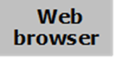

Fig.2.1 System Architecture

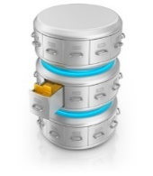

**Web Browser**

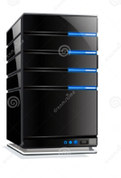



## 5.1 System Hardware Architecture

The proposed platform is a Web application written mainly in Object Oriented PHP with MySQL database. This is to ensure that the system is robust system that is scalable and can be improved to handle more users as it grows. The technical requirements are:

* PHP framework
* Apache Web Server
* The system will use a MySQL database.

This software package is developed using PHP, Java Script HTMLCSS and Bootstrap for front end.

* The Database is MYSQL Server as the back end to store the database.
* Operating System: the system should work on all OS platform (Windows, Linux or MAC)

3.2 System Software Architecture

The system shall interface with an Oracle or Mysql database. To implement the project we used Object Oriented PHP/HTML language for its more interactive and easy to understand and support*.*

***Server Side***

*Apache Webserver will accept all requests from the client and forward specific requests to server hosting this system. A development database will be hosted locally (using MySQL); the production database is hosted centrally (using Oracle).*

***Client Side***

*An OS capable of running a modern web browser which supports HTML version 5.*

3.2 Internal Communications Architecture

* + SMTP will be used to facilitate communication via email
  + The HTTP protocol will be used to facilitate communications between the client and server.
  + The Port number used will be 80.
  + This System can be accessed through Google Chrome and Mozilla Firefox web browsers.

## 6. FILE AND DATABASE DESIGN

The database will consist of 5 functional tables.

1. **Admin table**

This table will store all the personal details for the dean of students. This will include,user name and password of the dean of students.

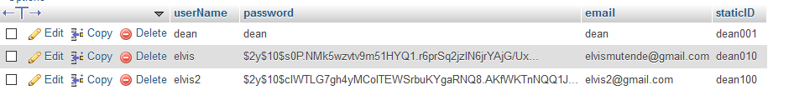

Fig.3.1 Admin Table

1. **Counselor’s table**

This table will store all the counsellor’s details in the Dean of students’ office. This will include, counsellors name, phone number their email and password.

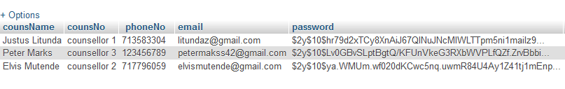

Fig.3.2 Counselors table

1. **Schedules table**

This table will be used to store all the data about schedules set by counsellors. The fields will include away time, date, period, Next time available, next data available, reason for being away, approval,counsellors number and counsellors name.



Fig.3.3 Schedules table

1. **Session table**

This table consists of the session set by the student. The details are students registration number, student registration number, counsellors booked (counselors number), session date, session start time and session end time

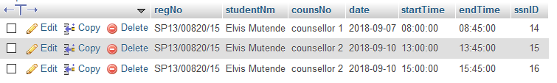

Fig.3.4 Session table

1. **Student table**

This table will contain students details such as userid,user email, user password, student registration number ,students name and phone number.



Fig.3.5 Student Login table

## 6.1 Database Management System Files

1. Text files (names and passwords)
2. SQL statements to

**.** DBMS SCHEMAS

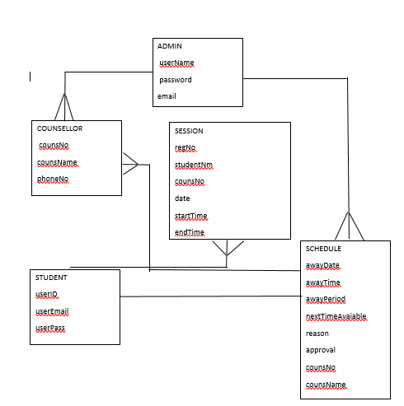

4.2 Non-Database Management System Files

* CSV database files used as inputs
* PHP files – will be used for displaying the output and formatting
* Documents (PDFs, spreadsheet and word docs) – For displaying reports
* IMAGES (.jpg, .png)
* Mail files

## 7.HUMAN-MACHINE INTERFACE.

## HOMEPAGE LAYOUT

The homepage layout will be designed to provide the user with hyperlinks to other pages.

It will lead to the following pages;

a) Students

b) Counsellors

c) Dean

d)About Us

e) Contact Us

## Color scheme

The key to effective use of color is simplicity. This system will avoid the use of screaming colors or luminous. The system will stick with the following colours

* Blue
* Green
* Brown.

## Information presentation

The system will avoid cluttering a page with irrelevant data. Forcing an operator to search for the required information increases response time and potential errors. The system shall have a consistent set of menu buttons and functions from screen to screen.

5.1 Inputs

All data will be entered manually to the system by use of a keyboard and mouse on a computer through data entry screens and forms.

The inputs consist of the query to the database. In this project, the inputs will be the queries as fired by the users like create an account, change password and set schedule.

1. **Student Login Form**

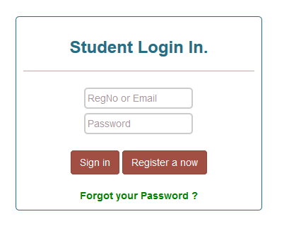

Fig.4.1 Student Login form

Fig.4.2 Student registration form

1. **Student Registration Form**

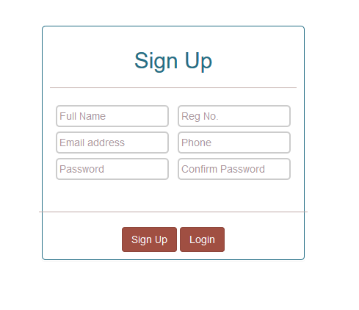

## 7.1 Outputs

The output consists of reports generated by the Dean of students on the schedules set.

Other outputs also include;

* Booked appointments
* Available counsellors

## 7.2 GUI

The system provides good graphical interface for the students and the administrator who is the dean of students to operate on while performing their tasks such as create user, set schedule ,and reset password.

* The user interface is responsive.
* All the modules provided with this system must fit into this graphical user interface and accomplish to the standard defined
* The design is simple and all the different interfaces are in cool colours and display a good contrast.
* The user interface should be able to interact with the user and allow the user to perform their duties and play their roles as expected.
* No student can log in as a counsellor since the counsellors will be under the dean of students directly.

## 8 DETAILED DESIGN

This section provides the information needed for a system development team to actually build and integrate the hardware components, code and integrate the software modules, and interconnect the hardware and software segments into a functional product.

## 8.1 Hardware Detailed Design

Hardware Requirements.

* Computers (client) and a server to host the system
* Network.
* A well maintained printer (In case of hard copies)
* 2GB and above of RAM
* 2.0 GHz of processor or higher.
* 100 MB of hard disk space.

## 8.2 Software Detailed Design

The system will consist of several different functionalities

1. Dean of students Authentication & Authorization function
2. Dean can view sessions of students who have booked for counselling.
3. Counsellors authentication and authorization module.
4. Students sign up and login module
5. Student can search for booked Session
6. Dean of students Authentication & Authorization function

This consists of the Dean of Students login.

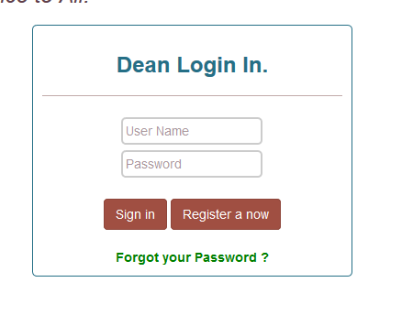

Fig.5.1 Login Interface

1. **Dean can view sessions of students who have booked:**

Before a student books for appointment.

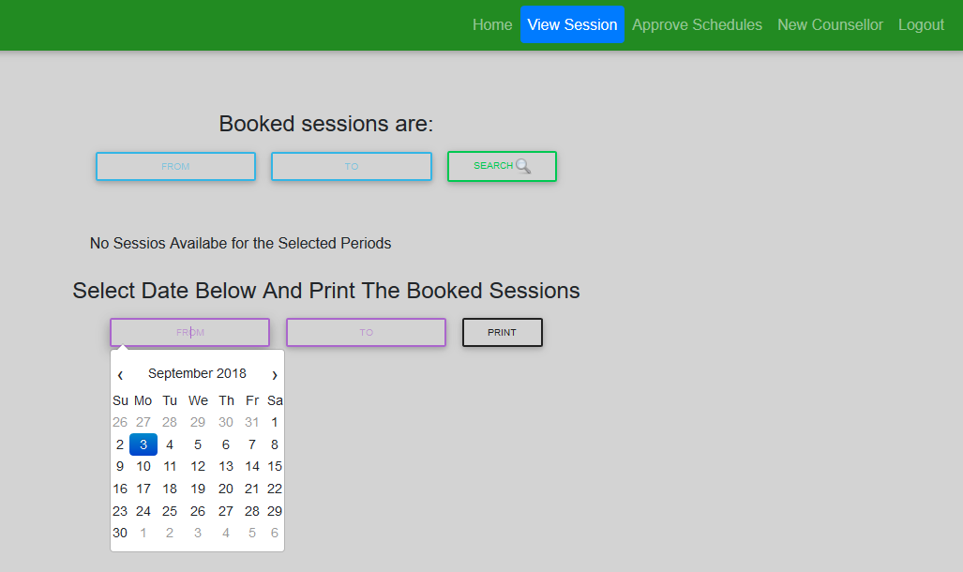

Fig.5.2a View sessions Interface

After a student has booked a session

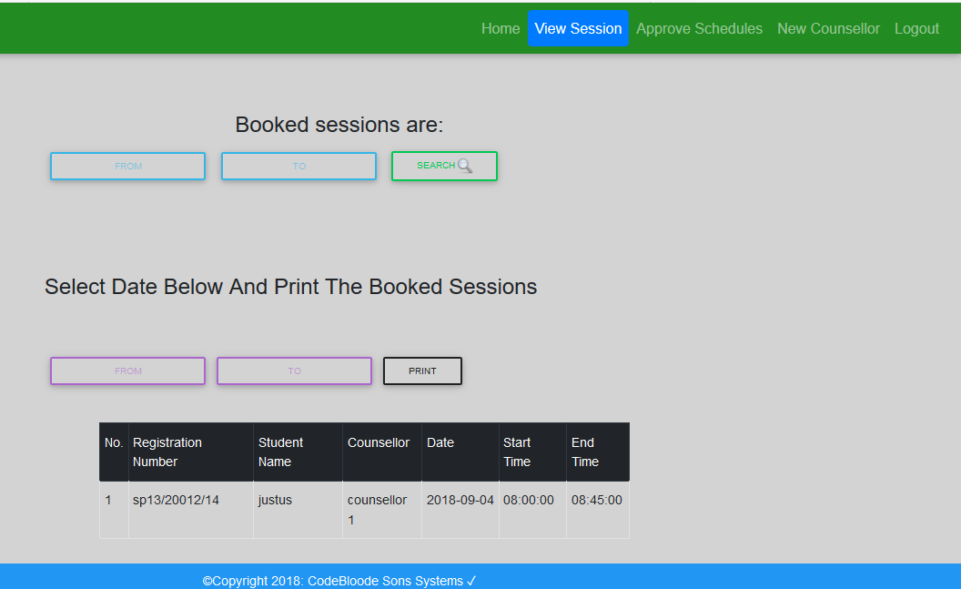

Fig.5.2b Booked appointment Interface

3.**Student can log in/Sign up**



Fig.5.3 Student sign up form

**4. Student can book Appointment:**

The student can book an appointment with the dean.

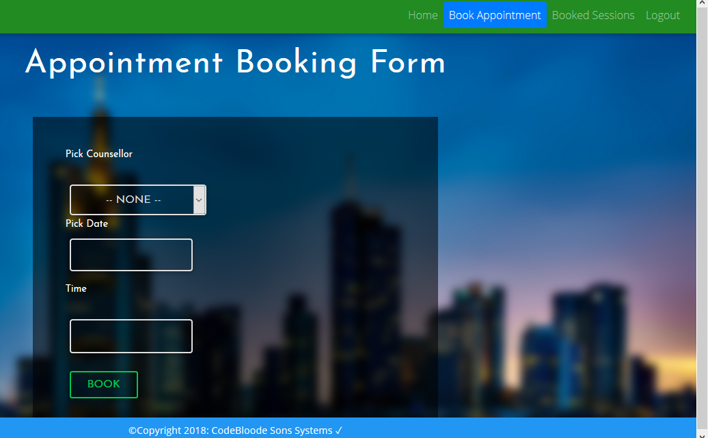

Fig.5.4 Student booking appointment interface

5. **Student Search Booked Session**

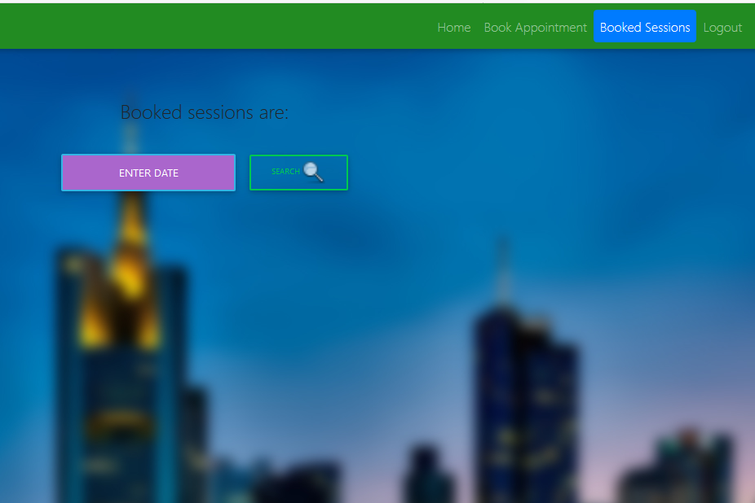

Fig.5.5 Student searching for a booked appointment interface

## 9 Use case Realization

This section contains diagrams showing the modelling of the use case. This use case shows the process of the counsellor setting a schedule, the student checking and selecting the available time and then booking an appointment, the dean making a follow up ,the dean can view appointment and print logs

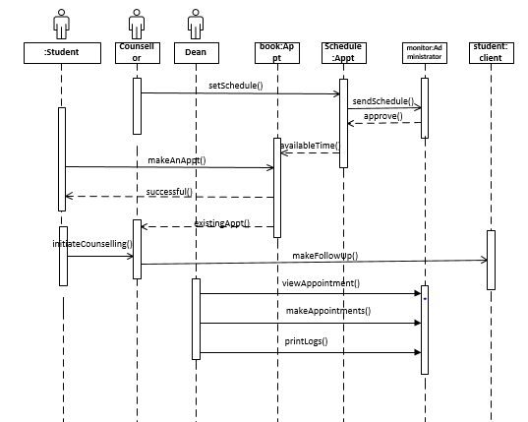

Fig.6.0 Sequence diagram for manager’s activities

Fig.6.0.Use case Diagram

## 10.0 SYSTEM INTEGRITY CONTROLS

The system will be protected against security threats. Security to the system will be provided with login and password. Even the passwords will be encrypted in the database to provide utmost security using the DBMS_CRYPTO package.

* User can reset forgotten password through email authentication.
* A counsellor will not have the rights to add another counsellor.
* Only the dean of students will have the rights to view a counsellor’s leave or absence request.
* Information input restrictions.

*Only registered user will use information system.*

* Information input accuracy, completeness, and validity

*Information put on the system will be checked for accuracy, completeness, and validity. (Moderate)*

* Error handling

*Error messages will be provided by the system.*

# TEST PLAN

## INTRODUCTION

## 11.1 PURPOSE

This test plan describes the testing approach and overall framework that will drive the testing Online Counselling Appointment Booking System.

It includes:

* Test Strategy: this refers to the rules that the project testing will be based on given the start date and end date. These could include, Objectives, assumptions, creation of test cases, specific tasks to perform, scheduling, data, and strategy e.t.c.
*  Execution Strategy: describes how the test will be performed and process to identify and report
* Defects, and to fix and implement fixes.
*  Test Management: process to handle the logistics of the test and all the events that come up
* During execution (e.g.: communications, escalation procedures, risk and mitigation, team roster).

## 11.2 AUDIENCE

* Project team members perform tasks specified in this document, and provide input and recommendations on this document.
* Project Manager Plans for the testing activities in the overall project schedule, reviews the document, tracks the performance of the test according to the task herein specified, approves the document and is accountable for the results.
* The stakeholders’ representatives and participants may take part in the testing to ensure the booking effective.
*  Technical Team ensures that the test plan and deliverables are in line with the design, provides the environment for testing and follows the procedures related to the fixes of defects.
* The Counselling Department officials will provide their inputs on functional changes.

## 12. TEST STRATEGY

### 12.1.1 Test Objectives

1. The objective of the test is to verify that the functionality Online Counselling Appointment System works according to the specifications.
2. The test will execute and verify the test scripts, identify, fix and retest all high and medium severity defects per the entrance criteria, prioritize lower severity defects for future fixing.

### 12.1.2 Test Assumptions

1. Production like data required and be available in the system prior to start of Functional Testing
2. Exploratory Testing would be carried out once the build is ready for testing.
3. Project Manager/BUSINESS ANALYST will review and sign-off all test deliverables.
4. The project will provide test planning, test design and test execution support.
5. Project team has the knowledge and experience necessary, or has received adequate training in the system, the project and the testing processes.
6. The system will be treated as a black box; if the information shows correctly online and in the reports, it will be assumed that the database is working properly.
7. During Functional testing, testing team will use any available data at the time of execution.
8. Users have basic computer knowledge.

### 12.1.3 Test Principles

1. Testing will be focused on meeting the objectives, cost efficiency, and quality.
2.  There will be common, consistent procedures for all teams supporting testing activities.
3.  Testing processes will be well defined, yet flexible, with the ability to change as needed.
4.  Testing activities will build upon previous stages to avoid redundancy or duplication of effort.
5.  Testing environment and data will emulate a production environment as much as possible.
6.  Testing will be a repeatable, quantifiable, and measurable activity.
7.  Testing will be divided into distinct phases, each with clearly defined objectives and goals.
8.  There will be entrance and exit criteria.

### 12.1.4 Data Approach

In functional testing, the Tester will provide data to test the activities.

## 12.2 Scopes and Levels of Testing

### 12.2.1 Functional Testing

Functional testing will be performed to check the functions of application. The functional testing is carried out by feeding the input and validates the output from the application.

The test will be performed according to functional requirements of the system.

In our system, ORMS this test will be done based on data provided by the tester.

### 12.2.2 System Testing

System testing of software will be done on a complete, integrated system to determine if it meets the specified requirements.

### 12.2.3 Integration Testing

This test is carried out to confirm if the various parts of the system are working together collaboratively. This will be done to ascertain that enough connection and integration of various system users was integrated.

### 12.2.4 Regression Testing

This will test to see if any component which was added to the system has any effect on the existing ones. Especially components pertaining non-functional requirements.

### 12.2.5 User Acceptance Testing

This test focuses on validating the business logic. It allows the end users to complete one final review of the system prior to deployment.

It is performed by the end users.

Since the users are the most indicated to provide input around business needs and how the system adapts to them, it may happen that the users do some validation not contained in the scripts. Test team write the UAT test cases based on the inputs from end user and Business Analyst’s.

## 12.3 Testing Deliverables

|  |  |  |
| --- | --- | --- |
| **Deliverable Name** | **Author** | **Reviewer** |
| Test plan | Test lead | Project manager, system analyst |
| Functional test cases | Test team | System analyst |
| Logging details | Test team | Programmer |
| Report generation | Test team | Test lead, project manager |

## 12.4 Test Environment

|  |  |
| --- | --- |
| Application url | http://127.0.0.1:8080 |
| App server | local host |
| operating system | Windows, Linux, MAC |
| web browser | Mozilla Firefox, Chrome, UC browser, chrome |
| Database | MySQL |

## 12.5 Levels and Impacts of the Defects

|  |  |
| --- | --- |
| **Severity** | **Impact** |
| Critical | This bug is critical enough to crash the system, cause file corruption, or cause potential data loss.  It causes an abnormal return to the operating system (crash or a system failure message appears).  It causes the application to hang and requires re-booting the system. |
| High | It causes a lack of vital program functionality with workaround. |
| Medium | This Bug will degrade the quality of the System. However there is an intelligent workaround for achieving the desired functionality.  This bug prevents other areas of the product from being tested.  However other areas can be independently tested. |
| Low | There is an insufficient or unclear error message, which has minimum impact on system use. |
| Cosmic | There is an insufficient or unclear error message that has no impact on system use. |

## 13. ROLES AND EXPECTATIONS

## 13.1 Project Manager

Project Manager: reviews the content of the Test Plan, Test Strategy and Test Estimates signs off on it.

## 13.2 Test Lead (Test Planning)

1. Ensure entrance criteria are used as input before start the execution.
2. Develop test plan and the guidelines to create test conditions, test cases, expected results and execution scripts.
3. Provide guidelines on how to manage defects.
4.  Attend status meetings in person or via the conference call line.
5.  Communicate to the test team any changes that need to be made to the test deliverables or application and when they will be completed.
6. Provide on premise or telecommute support.
7.  Provide functional (Business Analysts) and technical team to test team personnel (if needed).

## 13.3 Test Team

1. Develop test conditions, test cases, expected results, and execution scripts.
2.  Perform execution and validation.
3.  Identify, document and prioritize defects according to the guidance provided by the Test lead.
4.  Re-test after software modifications have been made according to the schedule.
5.  Prepare testing metrics and provide regular status.

## 13.4 Test Lead

1.  Acknowledge the completion of a section within a cycle.
2.  Give the OK to start next level of testing.
3.  Facilitate defect communications between testing team and technical / development team.

## 13.5 Development Team

1.  Review testing deliverables (test plan, cases, expected results) and provide timely feedback.
2.  Assist in the validation of results if requested.
3.  Support the development and testing processes being used to support the project.
4.  Certify correct components have been delivered to the test environment at the points specified in the testing schedule.
5.  Keep project team and leadership informed of potential software delivery date slips based on the current schedule.
6.  Define processes/tools to facilitate the initial and ongoing migration of components.
7.  Conduct first line investigation into execution discrepancies and assist test executors in creation of accurate defects.
8.  Implement fixes to defects according to schedule.

# USER MANUAL

## 14.1 GENERAL INFORMATION

General Information section explains in general terms the system and the purpose for which it is

Intended.

## 14.2 System Overview

Online Counselling Appointment Booking System is an application that manages the appointments at the Deans office. A system that will allow students book appointments to see counsellors and the dean of Students in Egerton University Njoro Campus. It will operate in windows/Unix Environment and will be web based system. The system should be able to lift data from existing student’s portal database.

6.4Organization of the Manual

The user’s manual consists of five sections: General Information, System Summary, Getting Started, troubleshooting and support. General Information section explains in general terms the system and the purpose for which it is intended. System Summary section provides a general overview of the system. The summary outlines the uses of the system’s hardware and software requirements, system’s configuration, user access levels and system’s behavior in case of any contingencies. Getting Started section explains how to get OCABS and install it on the device. The section presents briefly system menu and provides a detailed description of system functions. Troubleshooting and support section helps a way of troubleshooting and seeking help whenever the problems are encountered.

## 14.3 SYSTEM SUMMARY

System Summary section provides a general overview of the system. The summary outlines the uses of the system’s hardware and software requirements, system’s configuration, user access levels and system’s behavior in case of any contingencies.

## 14.4 System Configuration

OCABS operates on both windows and UNIX operating system. The application requires connection to Internet in order to save data to database, book appointments, set schedules, print schedules and approve the schedules. The appointments and schedules can be viewed using any major internet browsers. After installation on the device, OCABS can be used immediately without any further configuration.

## 14.5 User Access Levels

Only registered users are supposed to interact with the system, where the students book appointments to see the counsellor, the counsellor to set schedules and the dean to oversee all the activities.

## 14.6 Contingencies

In case of no internet a student cannot book the appointment.

## 15.0 GETTING STARTED

Getting Started section explains how to get OCABS and install it on the device. The section presents briefly system menu.

## 15.1 Set – up consideration

To optimize your access to the OCABS application:

* Make sure that the computer or smartphone has the internet access.
* Use the internet browsers e.g*. Chrome, Firefox, Internet Explorer.*

## 15.2 Accessing the system

To access the system:

1. Open your favorite web browser.
2. Type in the search bar the URL of the system in the search bar (<http://127.0.0.1/Online-Appointment-Booking-System/>).

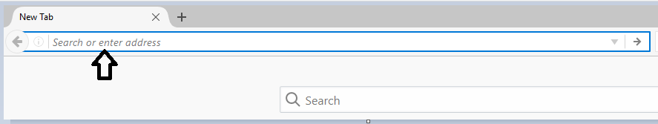

*Figure 1 search bar to input the URL of the system.*

1. To log in the system, students to provide their registration numbers and the password. The counsellor to give out the password and the counsellor number and the dean to provide the password.

### 15.2.1 System Organization & Navigation

The functions of the system are described in the system menu below:

After entering the URL of the system in the web browser, the following page appears:

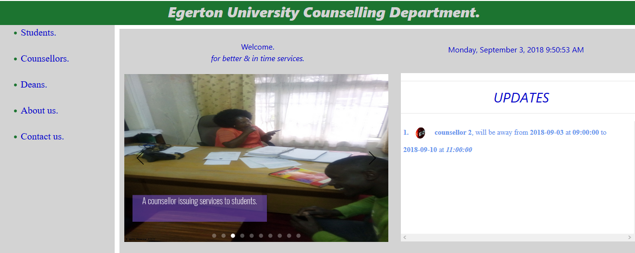

The respective users to select their section.

### 15.2.1 Student activities

**Student log in**

For students, choose the student section. If registered you can log in in the window below on the left of the screen. And if unregistered you can register as the new user. In case of the forgotten password, click the “forgot password?” link below the sign up and sign in tabs.

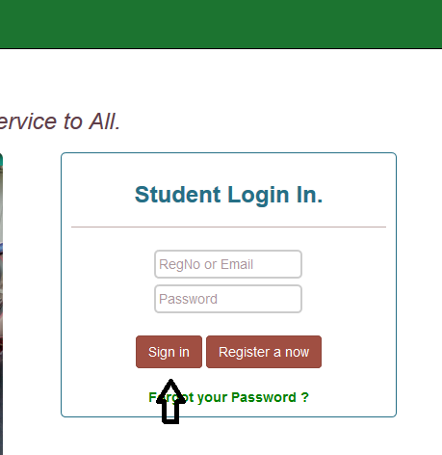

After a successful log in , a page appears with four tabs [Home](http://127.0.0.1/Online-Appointment-Booking-System/student.php) ,[Book Appointment](http://127.0.0.1/Online-Appointment-Booking-System/studentbookappPage.php) ,Booked Sessions, [Logout](http://127.0.0.1/Online-Appointment-Booking-System/students/logout.php) .When you select Home tab you maintain the same page.

Booking Appointment

You can select Book Appointment tab to proceed to the bookings.

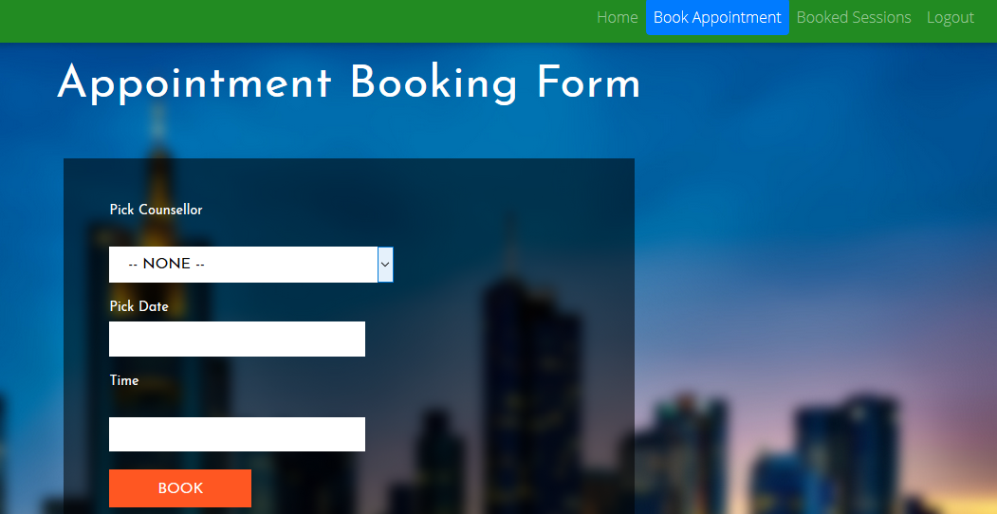

The student is required to pick the counselor, pick date and pick time. Finally click the book tab complete the booking process.

Viewing booked sessions

When you want to view the booked sessions, click the tab “Booked Sessions”

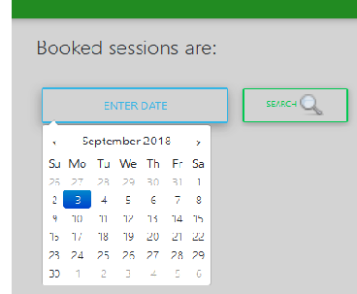

On the page enter the date dates you want to view the sessions booked and then click search icon to extract the sessions.

When done with the functions you can logout by clicking the logout tab. The page will redirect you back to the log in page**.**

## Counsellor activities

Counsellor log in

On the main page click the Counsellor link. A log in page will pop up.

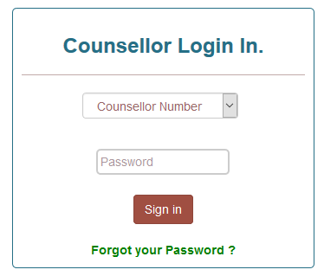

Select the Counsellor Number. Enter the password and click “Sign in” button to log in Incase you forget your password, click the “Forgot your Password?” link to reset the password.

After a successful log in the following page should appear. It has three tabs” home, View Appointments, Set Schedule and log out”

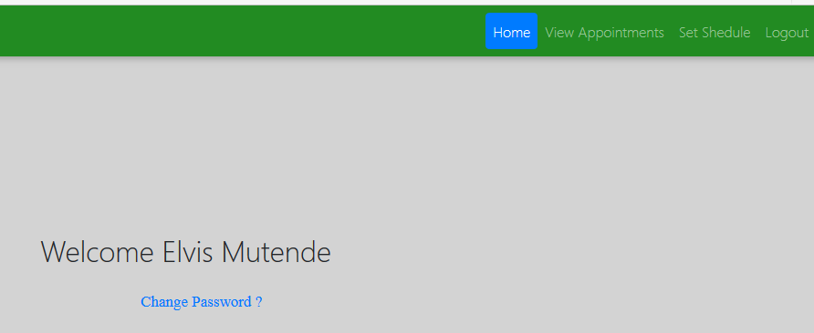

Counsellor change password

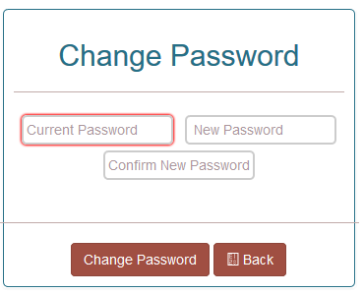

By any case you want to change the password, click the “Change Password?” link. You will be redirected to the following page. You are required to provide the current password, new password and then confirm the new password. Finally click the Change Password tab to complete the process. Back tab for getting you back to the Counsellor’s home page.

View Appointments

To view the appointments click the “View Appointments” tab. You will be required to input the date and then click the search icon to search the appointments.

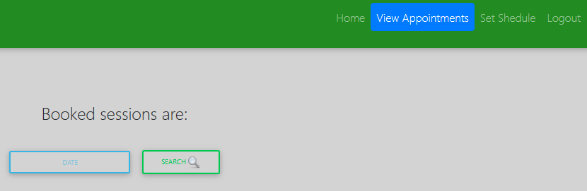

Set Schedule

On the page, select the date you will be away ,time to be away, number of hours to be away and the days to be away. You are also required to give the reason for being away. Finally click the “Set” button to set the schedule.

In case you want to set the schedule click the “Set Schedule” tab.

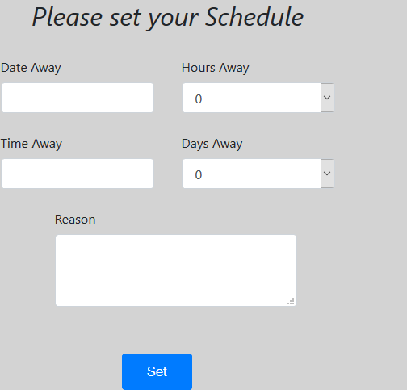

### 15.2.2 Dean Activities

**Dean log in**

On the main page, select the “Deans “link that will take you to the log in page, where the dean is supposed to log in.

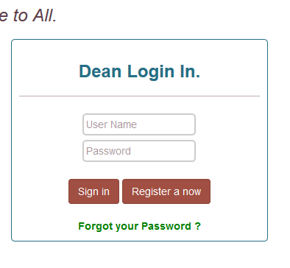

Provide the username and password if already registered. Click “register now” to register or click the “Forgot your Password” to reset the password.

After a successful log in you will be directed to this page.

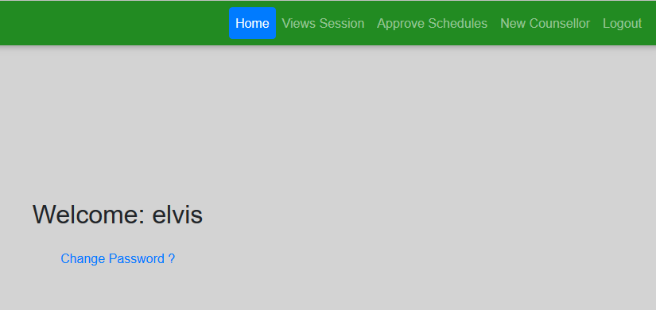

It has five tabs([Home](http://127.0.0.1/Online-Appointment-Booking-System/dean/dean.php?msg=logged%20in%20Successfully) ,[Views Session](http://127.0.0.1/Online-Appointment-Booking-System/dean/viewsessionsPage.php), [Approve Schedules](http://127.0.0.1/Online-Appointment-Booking-System/dean/approveschedulePage.php) ,[New Counsellor](http://127.0.0.1/Online-Appointment-Booking-System/counsellors/counsellorSignupPage.php) ,[Logout](http://127.0.0.1/Online-Appointment-Booking-System/dean/backend/logout.php) )

Home button directs you to the home page

Dean change password

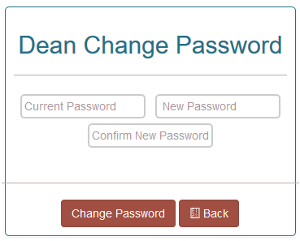

By any case you want to change the password, click the “Change Password?” link. You will be redirected to the following page. You are required to provide the current password, new password and then confirm the new password. Finally click the Change Password tab to complete the process. Back tab for getting you back to the Dean’s home page.

**Views Sessions**

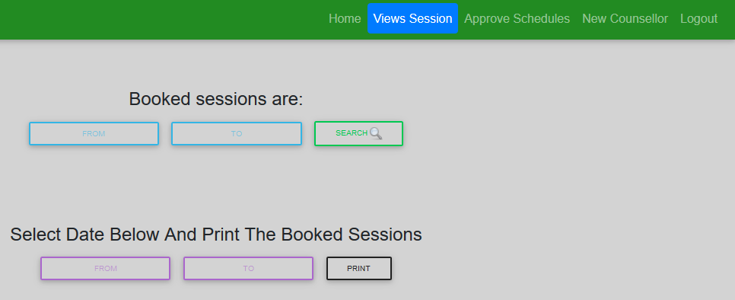

To view sessions, click the views session tab .To filter the sessions at specific dates, enter the first date and the second date .Click the search icon to search the sessions currently in the system.

Print sessions

To print the booked sessions enter the start date and the last date then click the print button to print out the booked sessions in PDF format.

Approve schedules

To approve the sessions click the approve session tab.

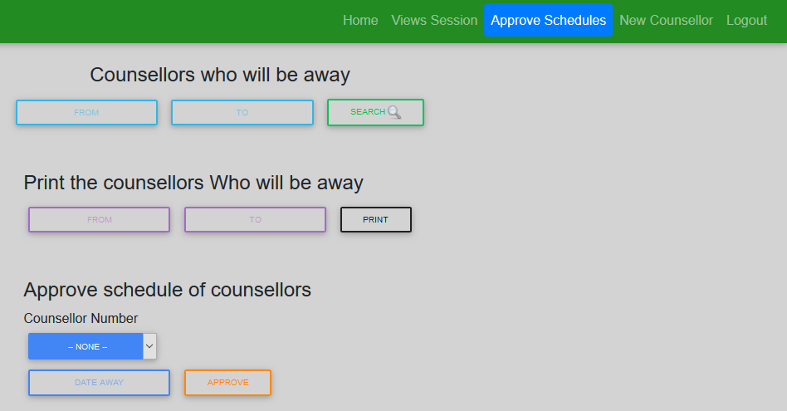

When you want view the counsellors who will away, input the two dates within which the counsellors are set to be away and click the search icon to retrieve the counsellors to be away on those dates.

Print counsellors away

You can also print the counsellors who will be away by inputting the two dates and click the print button.

To approve the schedules for the counsellors who will be away, select the counsellor number and the date he/she will be away and then click the approve button.

Register the counsellor

The dean can also create a new counsellor by clicking the New Counsellor.

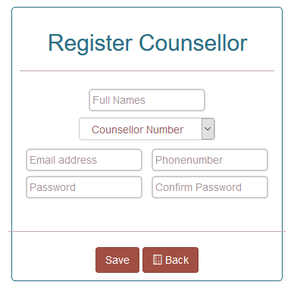

Provide the full names of the counsellors. Select the counsellor number. Provide the Email address, phone number and the default password for the counsellor. Click save button and back button to take you back to the home page of the dean.

### 15.2.3 About us

To get the information about the department click the about us link on the main page.

### 15.2.4 Contact us

It gives detailed information on how to reach the help desk.

### 15.2.5 Exiting the System

To exit the system, all users of the users are required to sign out. Close the tabs of the web browsers. You would have exited the system.

### 15.2.6 Troubleshooting and Support

In case of the problems with connectivity, contact the resource center stuff to sort out the internet problems.

### 15.2.7 Error Messages

The user is expected to receive error message when inputs the wrong password, user name or the email address.

## 16.***Support***

In case of the emergency assistance contact the following help desks.

Table 1 - Support Points of Contact

| Contact | Organization | Phone | Email | Role | Responsibility |
| --- | --- | --- | --- | --- | --- |
| Asst.Dean | Counselling Dept | **+254 0512217891/2** | dean@egerton.ac.ke | Assistant DOS | Student Welfare |

## Appendix

Appendix A: Acronyms

Table 2 - Acronyms

| Acronym | Literal Translation |
| --- | --- |
| OCABS | Online Counselling Appointment Booking System |
| PDF | Portable Document Format |
| DOS | Dean Of Students |

Appendix B: Approvals

The undersigned acknowledge that they have reviewed the User Manual and agree with the information presented within this document. Changes to this User Manual will be coordinated with, and approved by, the undersigned, or their designated representatives.

Table 3 - Approvals

| Document Approved By | Date Approved |
| --- | --- |
| Name: <Name>, <Job Title> - <Company> | Date |
| Name: <Name>, <Job Title> - <Company> | Date |
| Name: <Name>, <Job Title> - <Company> | Date |
| Name: <Name>, <Job Title> - <Company> | Date |